Support for Global Model Exchange (GME) Project Requirements

Within the caCORE SDK

This document contains the caCORE SDK team's understanding of and description of support for the Global Model Exchange (GME) Project requirements. Topics covered include:

Enabling Generation of SDK XSD and XML Mapping Files using GME Tags
- Enabling Validation of GME Project Tags within the UML Model
- GME Project Tag Validation Rules
- Assigning a GME Namespace Prefix to a UML Model
- Assigning a GME Namespace to a UML Package
- Assigning a GME Namespace to a UML Class
- Assigning a GME XML Element to a UML Class
- Assigning a GME XML Location Reference to a UML Attribute
- Assigning a GME Source or Target XML Location Reference to a UML Association Role Name

Enabling Generation of SDK XSD and XML Mapping Files using GME Tags
The generation of XSD and XML Mapping files (Castor XML serialization files) using GME Tags can be toggled on or off. To enable generation of XSD and XML Mapping files using GME tag values found within the UML model, set the GENERATE_XSD_WITH_GME_TAGS property located within the “/conf/deploy.properties” file to “true”, as highlighted below:
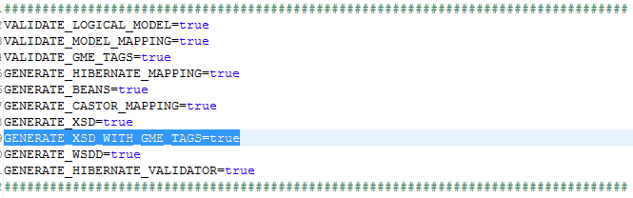
Note: The GENERATE_XSD_WITH_GME_TAGS property is ignored unless the GENERATE_XSD property is set to “true”.

Enabling Validation of GME Project Tags within the UML Model
The validation of GME Tags within a UML Model can be toggled on or off. To enable validation of any GME tag values found within the UML model, set the following deploy property located within the “/conf/deploy.properties” file to “true”, as highlighted below:
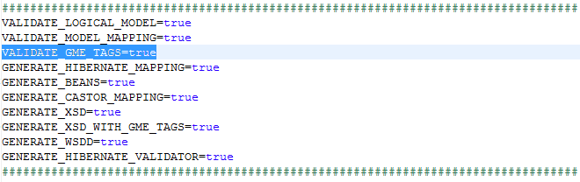
Note: The VALIDATE_GME_TAGS property is ignored unless both the GENERATE_XSD and GENERATE_XSD_WITH_GME_TAGS properties are set to “true”.

GME Project Tag Validation Rules
If enabled, the GME Tag validator enforces the following rules:
- Class names are not duplicated within a package;
- Attribute names are not duplicated within a class;
- Target association’s role names are not duplicated within the same class;
- Packages, classes, attributes, and association role names follow valid Java naming conventions;
- GME namespace prefix conforms to the following format: gme://<<Classification Scheme (UML Project Short Name)>>.<<Context>>/<<Classification Scheme Version>>/
- Certain GME tags can only be applied to certain UML elements, as follows:
  - A GME namespace tag (NCI_GME_XML_NAMESPACE) can only be applied to a UML Package or Class element
  - A GME class tag (NCI_GME_XML_ELEMENT) can only be applied to a UML Class element
  - A GME attribute tag (NCI_GME_XML_LOC_REF) can only be applied to a UML Class element
  - A GME association role name tag (NCI_GME_SOURCE_XML_LOC_REF or NCI_GME_TARGET_XML_LOC_REF) can only be applied to a UML Association element. Additionally, GME Association role name tag values (NCI_GME_SOURCE_XML_LOC_REF and NCI_GME_TARGET_XML_LOC_REF) must conform to the following format: "<GME rolename>/<class name>. Finally, the supplied class name needs to match either the source or target association end class names.

Assigning a GME Namespace Prefix to a UML Model
By default, the caCORE SDK code generator uses the NAMESPACE_PREFIX property located within the “/conf/deploy.properties” file whenever generating namespace related entries within the XSD and XML Mapping files:
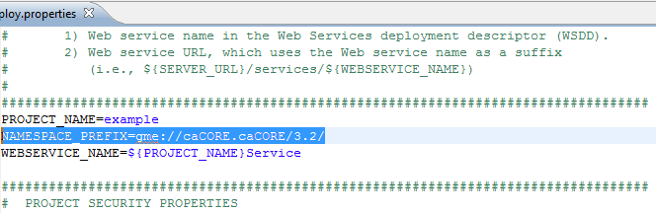
The namespace related XSD entries include the prefix value of the:
- “xmlns” attribute of the <schema> element;
- “xmlns:<<gme package name>>” attribute of the <schema> element;
- “targetNamespace” attribute of the <schema> element;
- “namespace” attribute of the <import> element, if any

The following diagram illustrates the XSD entries in question:
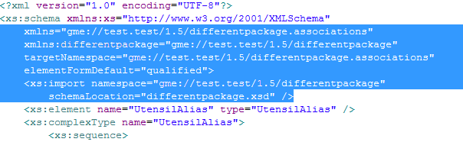
The namespace related XML Mapping entries includes the prefix value of the:
- “ns-uri” attribute of the <map-to> element;
The following diagram illustrates the XML Mapping entry in question:
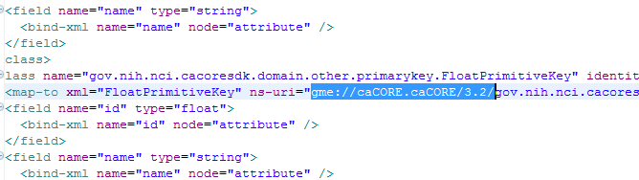
To effectively override the namespace prefix property using GME tags, apply the NCI_GME_XML_NAMESPACE tag to the root package of the UML Model. In the case of Enterprise Architect users, this would be the “Logical View” package shown in the Project View browser, as it is the “root” package selected prior to exporting the UML model to XMI for processing within the SDK:
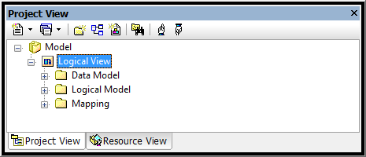
The following diagram illustrates the GME NCI_GME_XML_NAMESPACE tag as applied to the “Logical View” package:
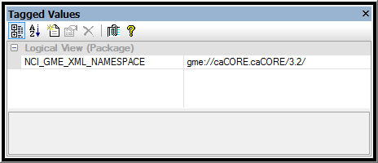
Note: In the case of the “root” package, only the namespace prefix is supplied. The appropriate package name is appended dynamically as each XSD/XML Mapping entry is generated.

Assigning a GME Namespace to a UML Package
By default, the caCORE SDK code generator uses the UML package element name whenever generating namespace related entries within the XSD and XML Mapping files.
The namespace related XSD entries include the value of the:
- “xmlns” attribute of the <schema> element;
- “xmlns:<<gme package name>>” attribute of the <schema> element;
- “targetNamespace” attribute of the <schema> element;
- “namespace” attribute of the <import> element, if any

The following diagram illustrates the XSD entries in question:
The namespace related XML Mapping entries includes the value of the:
- “ns-uri” attribute of the <map-to> element;
The following diagram illustrates the XML Mapping entry in question:
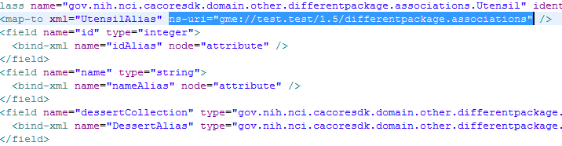
To effectively assign a name to a package using GME tags, apply the NCI_GME_XML_NAMESPACE tag to the desired package of the UML Model. In the case of Enterprise Architect users, this would be any of the “Logical Model” packages. An example is highlighted below in the Project View browser:
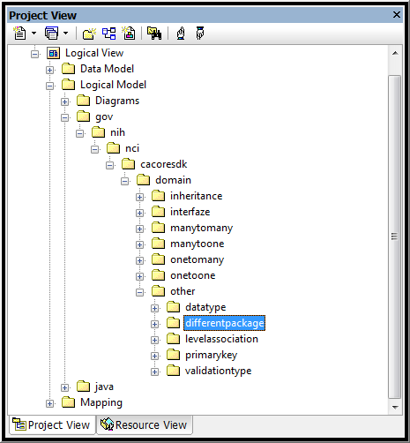
The following diagram illustrates the GME NCI_GME_XML_NAMESPACE tag as applied to the sample “differentpackage” package:
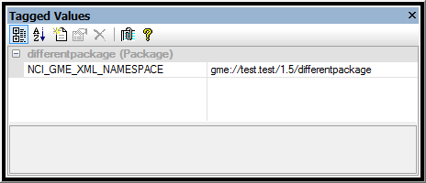
Note: When assigning a GME Namespace to a package, the complete namespace (the namespace prefix plus the package name) should be supplied as the tag value. In this case, the default namespace, including the default package name, is completely overridden; i.e., the default package name is not appended dynamically as is the case when generating each XSD/XML Mapping entries without using GME tags.

Assigning a GME XML Element to a UML Class
By default, the caCORE SDK code generator uses the UML Class element name whenever generating class related entries within the XSD and XML Mapping files.
The class related XSD entries include the value of the:
- “name” attribute of the <element> element;
- “type” attribute of the <elelment> element;
- “name” attribute of the <complexType> element;

The following diagram illustrates the XSD entries in question:
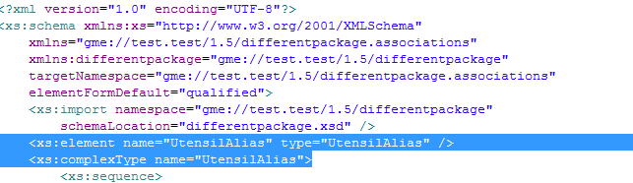
The class related XML Mapping entries includes the value of the:
- “xml” attribute of the <map-to> element;
The following diagram illustrates the XML Mapping entry in question:
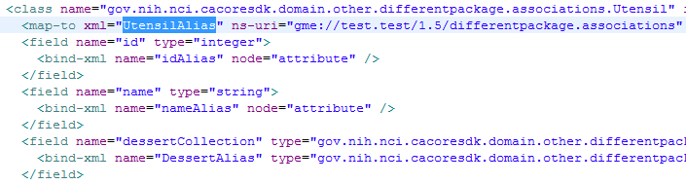
To effectively assign a name to a class using GME tags, apply the NCI_GME_XML_ELEMENT tag to the desired class of the UML Model. In the case of Enterprise Architect users, this would be any of the classes within one or more of the “Logical Model” domain packages. An example is highlighted below in the Project View browser:
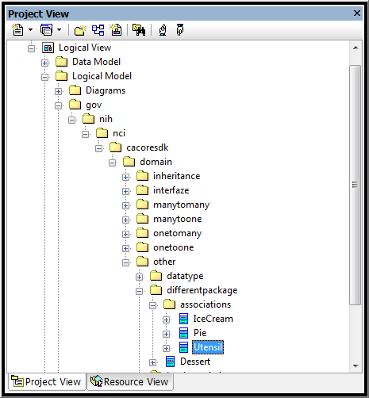
The following diagram illustrates the GME NCI_GME_XML_ELEMENT tag as applied to the sample “Utensil” class:
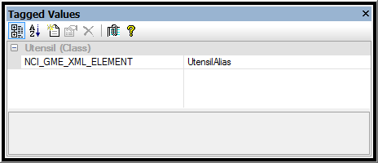
Note: When assigning a GME XML Element tag to a UML class, only the non-qualified class name without the package name prefix should be supplied.

Assigning a GME Namespace to a UML Class
By default, the caCORE SDK code generator uses the UML package element name when assigning a UML class to a given namespace and when generating namespace related entries within the XSD and XML Mapping files.
With support for GME tags, a class’ assigned package name can effectively be changed by applying the GME NCI_GME_XML_NAMESPACE tag to the desired class of the UML Model. Please refer to the Assigning a GME Namespace to a UML Package and Assigning a GME XML Element to a UML Class sections for more information.

Assigning a GME XML Location Reference to a UML Attribute
By default, the caCORE SDK code generator uses the UML Attribute element name whenever generating attribute related entries within the XSD and XML Mapping files.
The attribute related XSD entry includes the value of the:
- “name” attribute of the <attribute> element;

The following diagram illustrates the XSD entry in question:
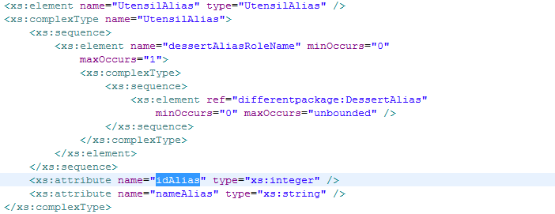
The attribute related XML Mapping entry includes the value of the:
- “name” attribute of the <bind-xml> element;
The following diagram illustrates the XML Mapping entry in question:
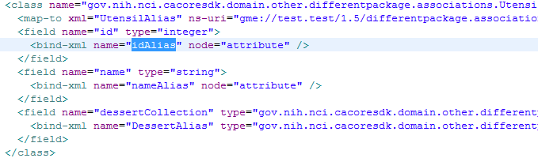
To assign a GME XML Location Reference to a UML attribute, apply the NCI_GME_XML_LOC_REF tag to the desired attribute. In the case of Enterprise Architect users, this would be any of the attribute elements found with a given “Logical Model” domain class. An example is highlighted below in the Project View browser:
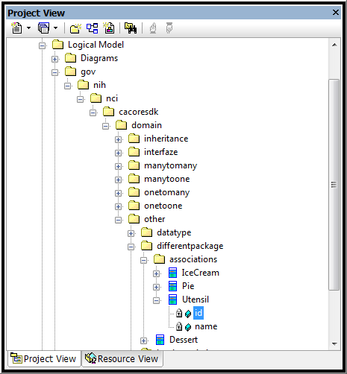
The following diagram illustrates the GME NCI_GME_XML_LOC_REF tag as applied to the sample “id” attribute of the “Utensil” domain class:
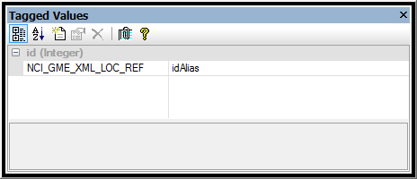

Assigning a GME Source or Target XML Location Reference to a UML Association Role Name
By default, the caCORE SDK code generator uses the Source or Target role name from the UML Association element whenever generating association role name related entries within the XSD and XML Mapping files.
The association role name related XSD entry includes the value of the:
- “name” attribute of the <element> element;

The following diagram illustrates the XSD entry in question:
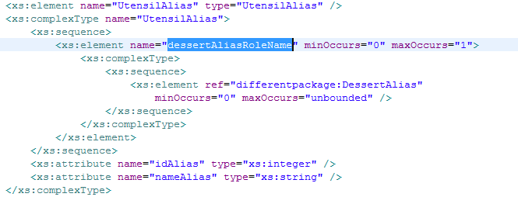
The association role name related XML Mapping entry includes the value of the:
- “location” attribute of the <bind-xml> element;
The following diagram illustrates the XML Mapping entry in question:
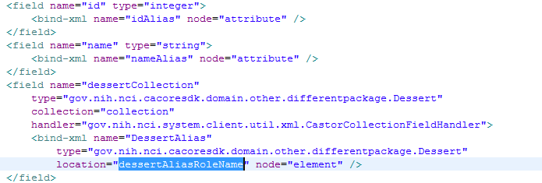
To associate a GME source or target XML Location Reference to an association role name, apply the NCI_GME_SOURCE_XML_LOC_REF and/or NCI_GME_TARGET_XML_LOC_REF tag(s) to the desired association link between two classes within the UML Model. In the case of Enterprise Architect users, this would be any association link within a UML class diagram. An example is shown below:
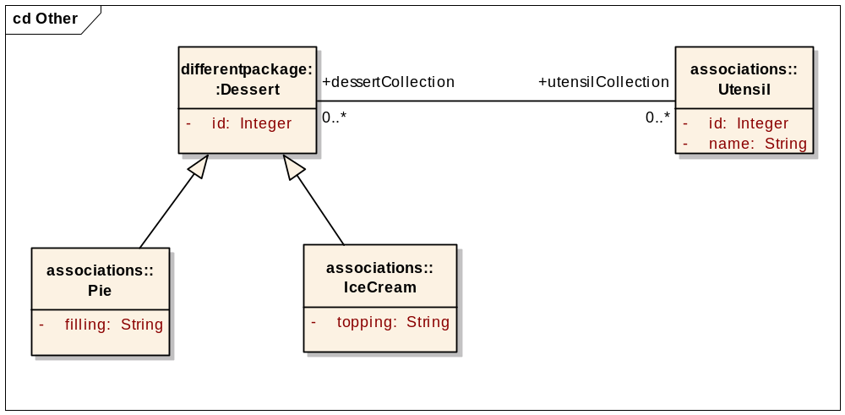
As shown above, the original source and target association role names are dessertCollection and utensilCollection. Note that the terms “source” and “target” are relative depending on which class was selected first when drawing the association between the “Dessert” and “Utensil” classes.
The following diagram illustrates the GME NCI_GME_XML_LOC_REF tag as applied to the association link between the sample Dessert and Utensil domain classes:
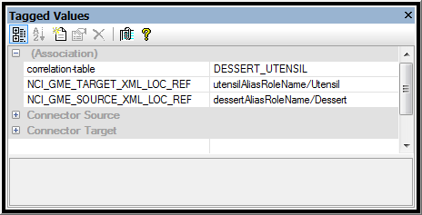
Note: The value of the GME tags must conform to the “<GME role name>/<original class name>” format.

Known Issues:
???

Known Limitations:
???

See Also:
For more information on GME Project requirements, please refer to the following:
- ???

